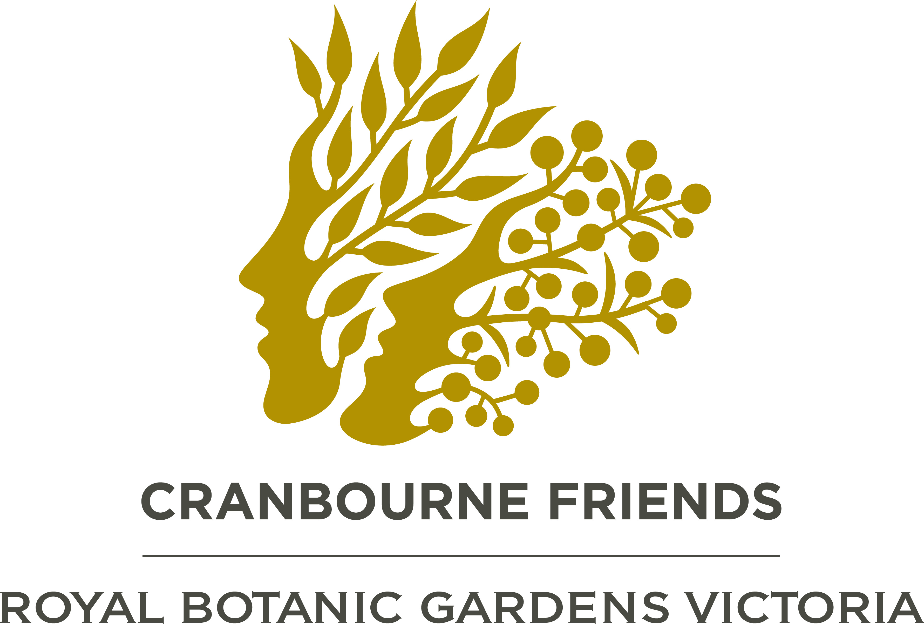
EVENTS BOOKING FORM – JUNE- JULY 2021
Cranbourne Friends Royal Botanic Gardens Victoria Inc. A0025281B ABN 43551 008 609
PLEASE NOTE – THIS IS IMPORTANT: IF WRITING BY HAND, PLEASE USE CAPITAL LETTERS EXCEPT FOR EMAIL ADDRESS

Event No: | Date of Event |  | EVENT and CONTACT PERSON |  | Book & Pay by | Price * member, non - member & student |  |  | Name/s of all participants - on a separate sheet if necessary.  FIRST & LAST NAMES MUST BE PROVIDED BELOW FOR ALL ATTENDEES |  | Total # participants |  | Total $$
2106 | Tuesday 13th July, 2021- 2pm |  | Walk and Gawk John Arnott:– Overview of the Australian Garden  Contact : Barbara Jeffrey  Email: bajeffrey@westnet.com.au  Phone: 0408 564 379 |  | Thursday, 8th July 2021 | Member  Non Member  Student |  | $15  $20  $ 5 |  |  | member  non-member  student
2107 | Sunday, 18th July. 2021- 2pm |  | Afternoon Talk: Alex Maisey :The Superb Lyrebird  Contact : Barbara Jeffrey  Email: bajeffrey@westnet.com.au  Phone: 0408 564 379 |  | Friday 9th July  2021 | Member  Non Member  Student |  | $20  $25  $10
*No GST is payable Total paid
Your Details: |  | Contact Name:
Membership Number Please - see Membership Card |  |  |  |  |  |  | Student Card Number - must be supplied with Booking
Phone no(s): |  | Home: |  | Mobile:
Address: |  |  |  |  |  |  | Suburb: |  |  | Postcode:
Email: Legible please!
Please supply All contact details for all attendees.

Assistance: Request for help from Members at Events
The organisers are looking for some help from the attendees of the above functions, either on the day or on the day before the function. If you would like to help, please circle one of the activities below. The coordinator of that activity will contact you with more details.
Assistance with: Set-up, gathering equipment, IT help, refreshments, clean-up, other.

□ I am willing to help with (Activity Name) | Name of Volunteer
Please go to page 2
PAYMENT OPTIONS: Please indicate which one you are using.
□ Electronic Funds Transfer
- Pay to: ‘Cranbourne Friends RBGV Inc.’
Bank account NAB: BSB 083 597 Account no. 516396798.
- In the description line, key in the letters ‘act’ plus your surname (or as many characters as will fit) e.g. actDavies
- Write that same information here… e.g. actDavies ………………………………………
- Then email or post a copy of your booking form*** and include details of your transfer receipt. Date of transfer, Name of your Bank, and amount transferred
See below for email and postal address.
□ Cheque – payable to ‘Cranbourne Friends Royal Botanic Gardens Victoria Inc.’
Post Booking Form with cheque or deposit receipt to address as per Postal Address.

□ Cash payment at bank. — At any National Australia Bank. Make payment to: ‘Cranbourne Friends Royal Botanic Gardens Victoria Inc.’
Post deposit receipt with Booking Form: See below for postal address.

Postal address - Friends Bookings, 350 Clyde-Fiveways Rd, Clyde. 3978. Email address – bookings@rbgfriendscranbourne.org.au

Enquiries: bookings@rbgfriendscranbourne.org.au
Booking and payment will be confirmed. Cancellation Policy will be included with confirmation of booking.

Cancellations: Please notify Barbara Jeffrey on 0408 564 379 if you are unable to attend an event. On the day: If you are unable to come at the last minute, phone the event organiser on their number.
In the event of extreme weather forecast, the Cranbourne Friends RBGV may cancel an outdoor activity. You will be informed and refunded.

****IF YOU ARE COMPLETING THIS FORM ON LINE, PLEASE SAVE IT TO YOUR COMPUTER FIRST AND THEN ATTACH IT TO YOUR EMAIL TO THE BOOKING OFFICER.

